Exercise: Producer – Consumer, Electrocardiography (ECG)

In this exercise, you will work with the collection and processing of electrocardiography (ECG) samples. In short, ECG is the process of recording the heart's electrical activity over time.

This exercise focuses on the producer-consumer pattern, which we will use to decouple the collection of samples from the processing of samples and allow collection and processing to run in separate threads.

An ECG signal is a continuous signal with – in a healthy person – looks similar to the one below. We will create a small system that can receive and process samples of such a signal periodically.

A self-taught l33t programmer has previously worked on the system and left a design for you:

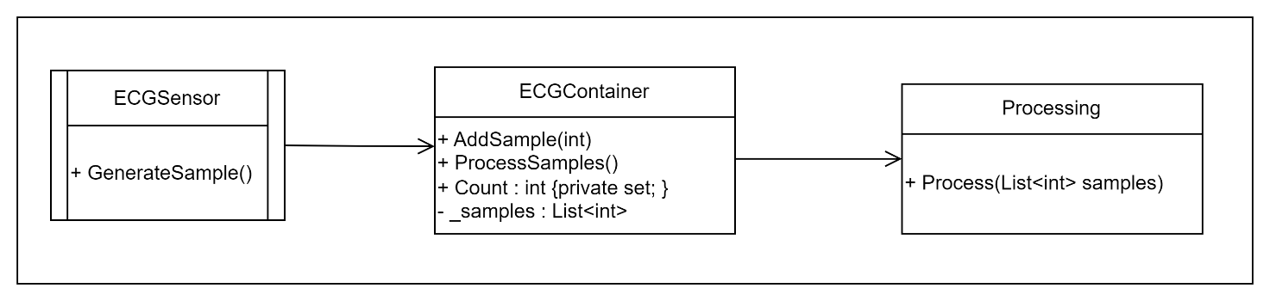

Being the brilliant and educated engineer you are, you immediately see that this is a bad design: The sensor, which provides samples knows the ECGContainer, which consumes samples. The ECGSensor is highly coupled to the ECGContainer.

Your job is to create a better design and implement it. You should work together with one or more other students when you do the design.

Exercise 1:
Consider the design above. How can you use the producer-consumer pattern and a queue (BlockingCollection) to decouple the ECGSensor from the ECGContainer?

Create a design for your system in the form of an UML class diagram.

Hint: You will probably need to introduce new classes for the ECGReadingProducer, the ECGReadingConsumer, and a DataContainer for the data being read from the ECGSensor and sent to the ECGContainer.

Exercise 2:
Show your design to another group and get their feedback. Decide if you want to change anything.

Exercise 3:
Implement your design as a console application and create a simulated version of the sensor.
The simulated sensor should be polled, i.e., you have to ask the sensor for a new sample and it shall return a value between 0 and 50. The polling frequency shall be once every second.

The producer- and the consumer-parts of your system shall run in separate threads. Every time the consumer receives a new sample it shall be printed to the console.

Exercise 4:
The ‘Process’ method on ECGContainer shall be called from the Main thread when the button ‘p’ is pressed.
The default processing is to print the complete list of samples.

Exercise 5:
Printing of the received samples should not be done by the consumer. We want a separate Log class for that.

Use the GoF Observer pattern to decouple the reception of the sample from the printing of samples. The Log class shall have the role of an Observer and the ECGReadingConsumer, which receives data from the BlockingCollection, shall have the role of a Subject.

Exercise 6:
If you have not done so already, the ECGContainer should also be decoupled from the ECGReadingConsumer, by making it an Observer of the ECGReadingConsumer.

